Debit Card Bank Name

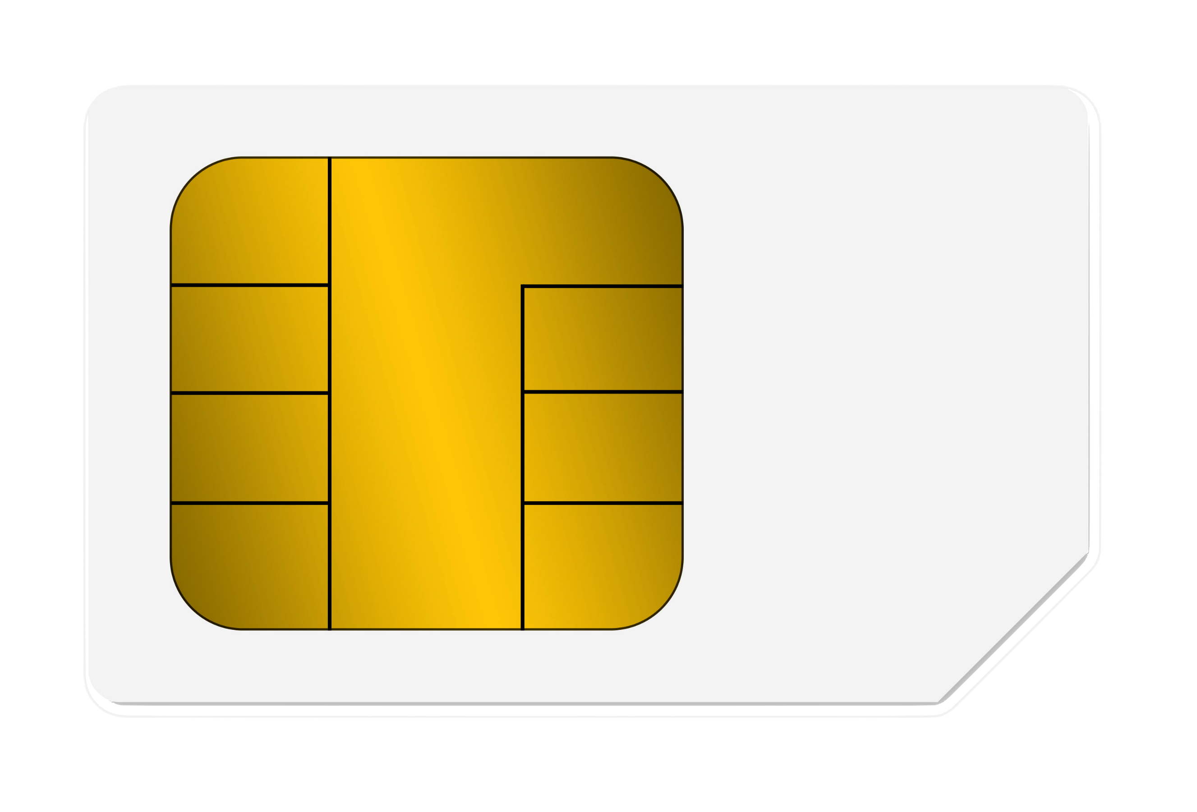

**1234 5678 9012 3456**

**0123 VALID>01/80**

**Card Holder Name VISA**